**Practical session 2**

*For the practical part of this lab please save the Python programs that you create and take screenshots of the execution (evaluation) of your programs.*

**Tasks:**

1. Write an algorithm that describes how to make scrambled eggs, try to use control words, like IF, WHEN, UNTIL, WHILE, WAIT, AND, OR.
2. Get at least 2-3 eggs, 2 table spoon of butter and ¼ cup of milk
3. Using a bowl mix all the ingredients together
4. When you have completed the mixing pour it into a pan and place it on the stove
5. Wait for the egg to set
6. When the egg is settled using a spoon break it down into small particles
7. Is Idle (the Python language shell) an Interpreter or an Compiler or both? Explain your answer.

It is an interpreter a reason why is because a statement which is provided from a source which includes the code therefore it has the ability to translate it into a machine code and gets rid of it.

3) Write a command in the Idle shell that says “Hello world”

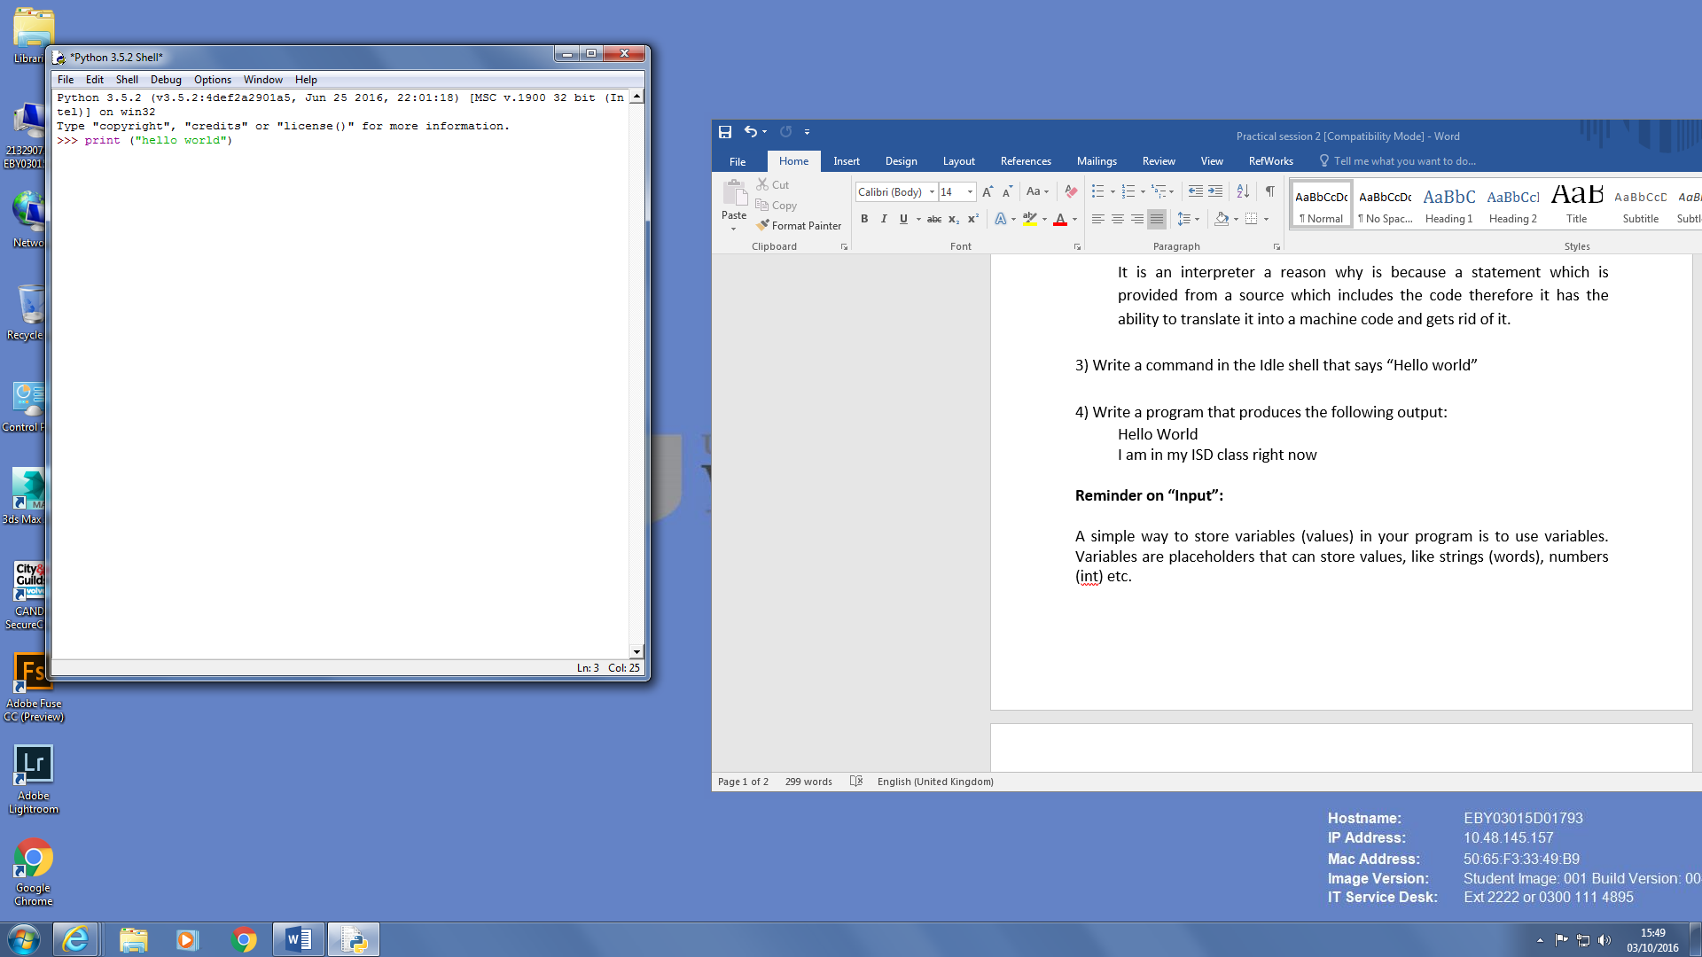

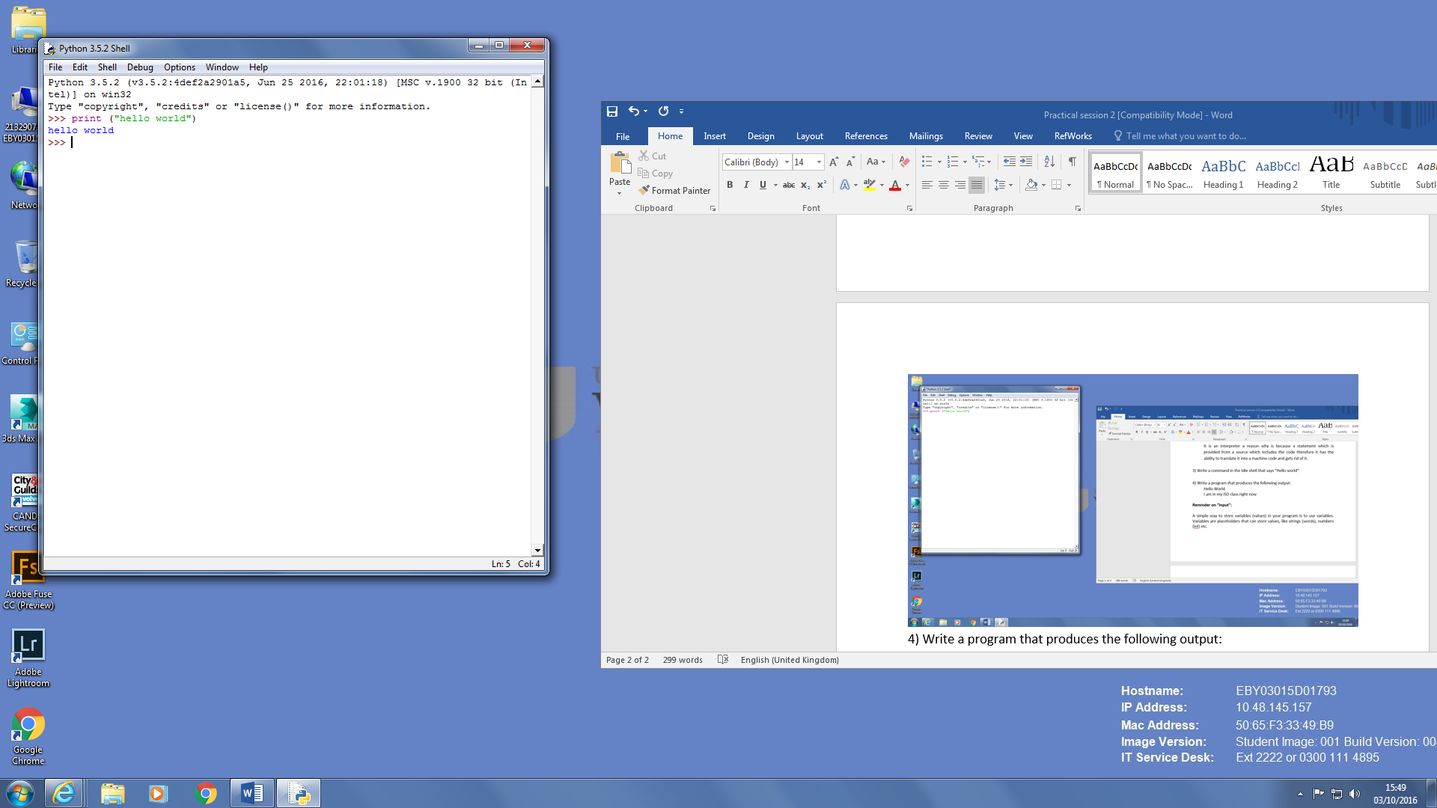

4) Write a program that produces the following output:

Hello World

I am in my ISD class right now

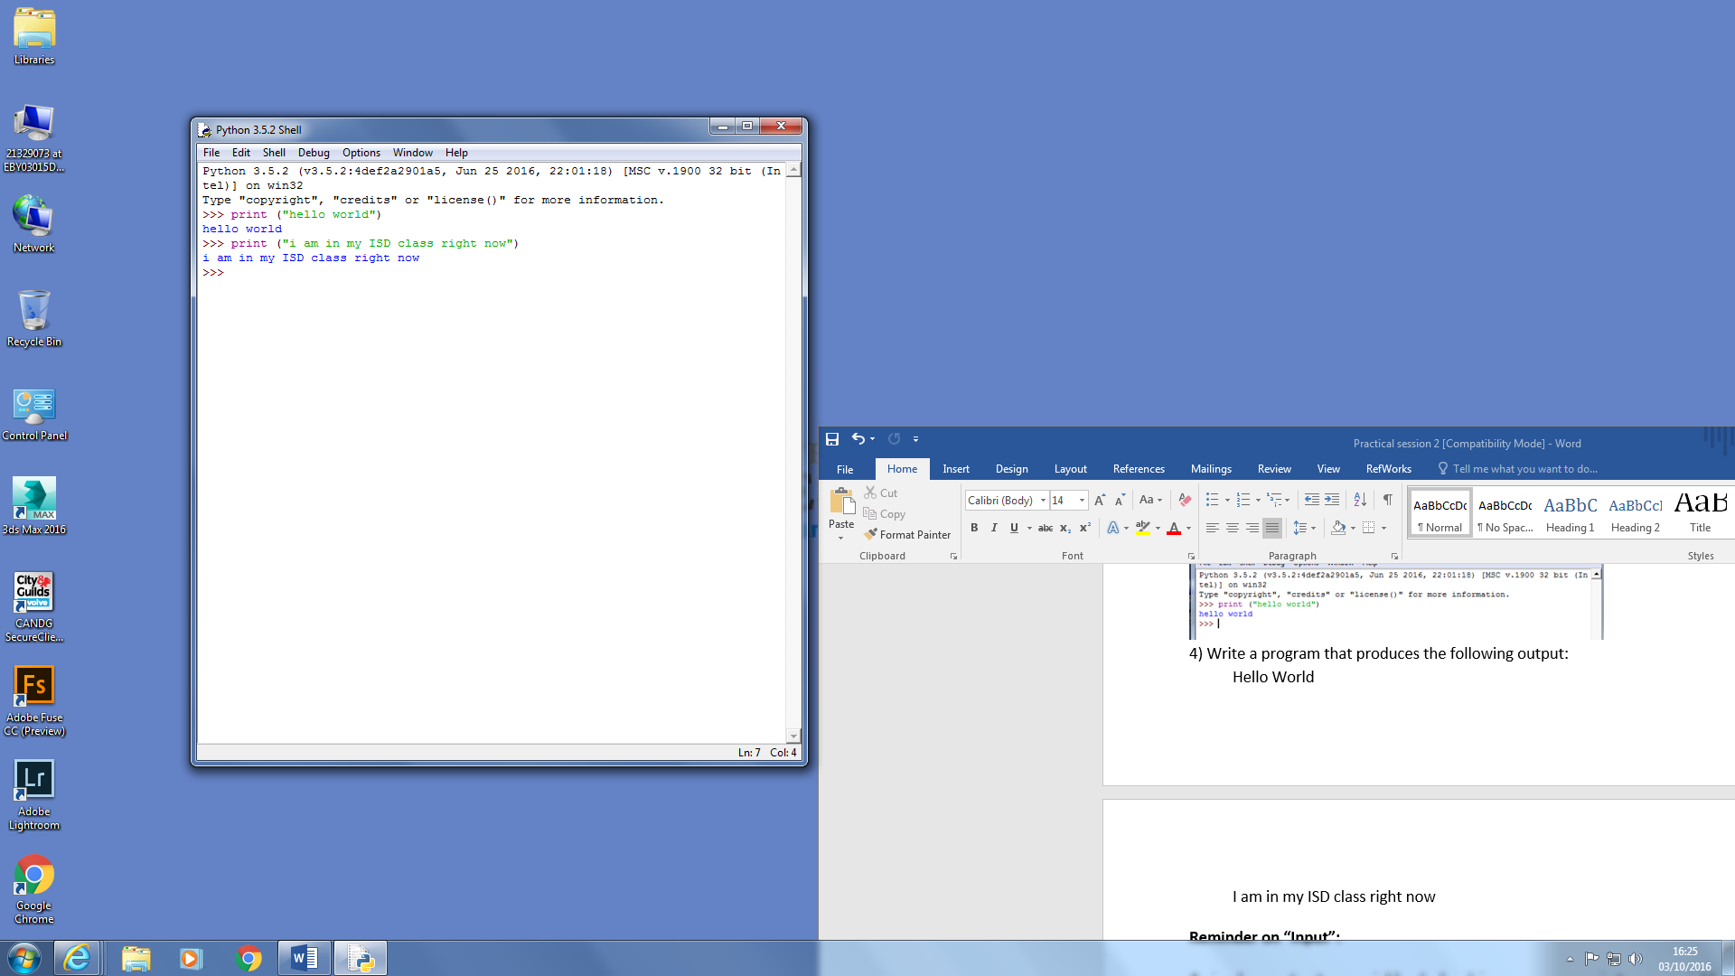

**Reminder on “Input”:**

A simple way to store variables (values) in your program is to use variables. Variables are placeholders that can store values, like strings (words), numbers (int) etc.

To create a variable, just give it a name and an initial value, for example for a number:

number = 7

or for a String (words):

myword = “This is my word”

5) Write a program that asks the user for his/her name and produces an output like:

Hi there, what is your name?

>User input to be read<

Hello

“User name”

How are you?